Open House Pfronten 2022
For the traditional Open House at the Pfronten location, DMG MORI is presenting its new developments and trends for machine tools for the first time with a two-week event.

Automated and digitized into the future

- Two weeks of experiencing state-of-the-art machine tool manufacturing up close.
- 14 holistic automation solutions live in operation, including four innovations: Robo2Go MAX, MATRIS light PH Cell 2000 and PH 50.
- Gear Cutting: Unique DMG MORI gear cutting solutions with standard machines and tools
- Innovative digital solutions for the future of manufacturing: Cell Controller LPS4, Digital Twin, TOOLING CAM & Store.
- 26 trend-setting machine tools including two world premieres: NTX 500 and DMU/DMC 85 H monoBLOCK.

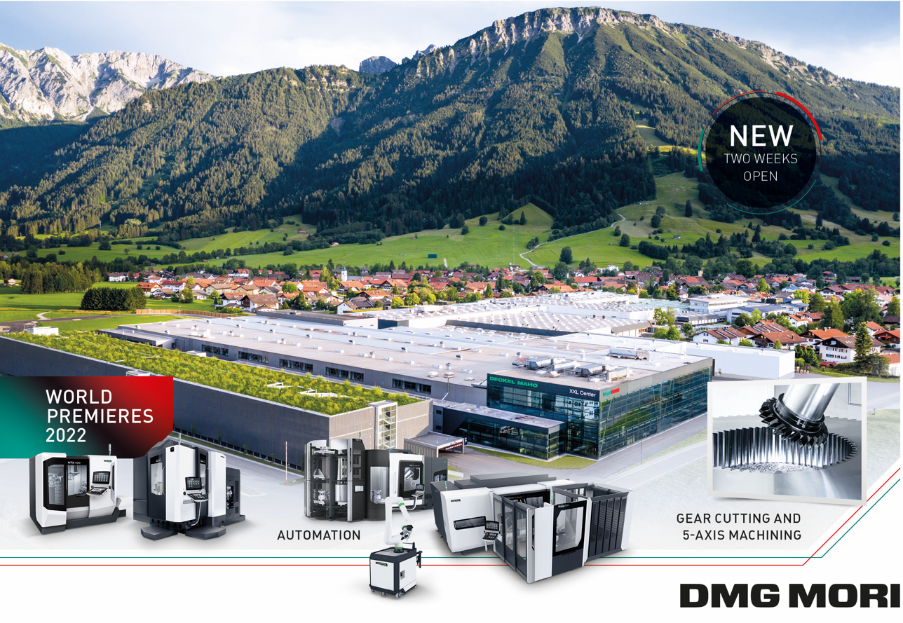
01
The traditional in-house exhibition in Pfronten extends in 2022
over two weeks for the first time.

Live and in presence, DMG MORI welcomes its visitors to the traditional in-house exhibition in Pfronten from May 9 to 21, 2022. To protect its health, DMG MORI has extended the exhibition period in order to reduce the daily number of visitors and to have more time for personal exchange. In the new, larger showroom, future-oriented and flexible automation solutions – 14 are on display – will be the central theme. In addition to proven products such as the automated guided vehicles (AGV), DMG MORI will present no less than four innovations: the Robo2Go MAX, the MATRIS light, the PH Cell 2000 and the PH 50. Even after the in-house exhibition, automation solutions such as these can be viewed in the permanently equipped showroom as well as at other locations. In the area of digitization, the focus will be on the Cell Controller LPS4, the Digital Twin, TOOLING CAM & Store. Two world premieres – the NTX 500 and the DMU/DMC 85 H monoBLOCK – complete the in-house exhibition, which will feature a total of 26 machines. A fixed component of the program is a large number of presentations that will be broadcast live and online from the DMG MORI Broadcast Studio.

“The PRE-EMO Show in September 2021 has once again confirmed to us how valuable personal encounters with our customers are,” says Cornelius Nöß, Managing Director of DECKEL MAHO Pfronten, looking ahead to the upcoming in-house exhibition. After a break last year, the traditional event year will now take place again in presence. He said that the reduced number of visitors during the PRE-EMO show had ensured high-quality discussions. “For this reason, we are stretching the 2022 in-house exhibition over two weeks for the first time, which will also protect the health of everyone involved.”

The 2022 in-house exhibition will once again be synonymous with cutting-edge CNC technology and groundbreaking trends in machine tool manufacturing – above all, innovative and holistic automation solutions. They remain an indispensable means for future-oriented users to work productively and competitively. As a pioneer in this field, DMG MORI supplies 57 automation solutions completely from a single source. At the Pfronten event, 14 of these can be seen, including the latest developments.

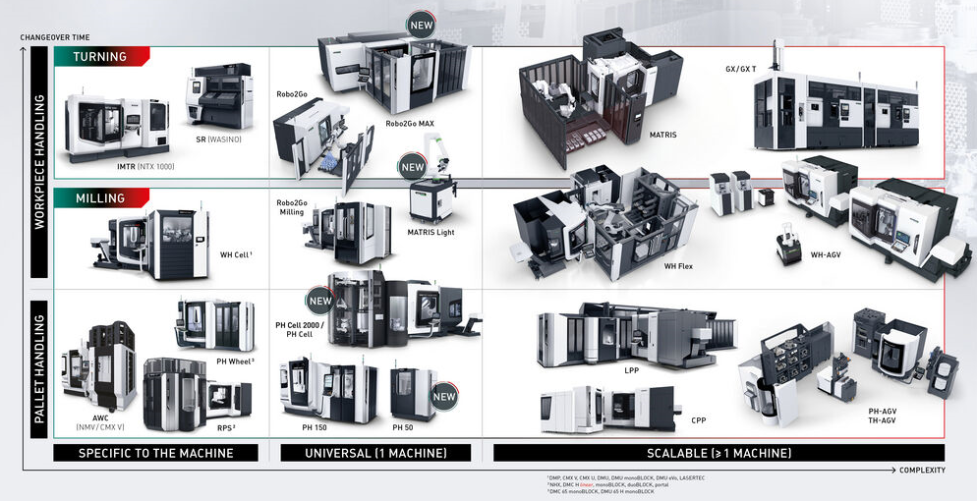
02
With 57 holistic automation solutions from a single source, DMG MORI increases the productivity of any production.
Automation: Robo2Go MAX
Flexible handling of workpieces with up to 115 kg
DMG MORI has developed the new Robo2Go MAX so that even the machining of heavy workpieces can be automated with maximum ease. In the strongest version, the robot is designed for handling components with a workpiece weight of up to 115 kg and a diameter range of ø 40 to ø 400 mm. This makes the Robo2Go MAX the ideal addition to the Robo2Go family and a suitable automation solution for large lathes and turn-mill centers – starting with the CLX 750 and CTX beta 2000, through the CTX beta 1250/2000 TC and the entire CTX gamma TC series, to some NLX and NTX sizes.

Automation: MATRIS light
Highly flexible & collaborative automation for workpieces up to 5 kg
on 1.4 m²
Production with variable mix and volume requires highly flexible automation solutions. With MATRIS Light, DMG MORI now presents a very space-saving and collaborative automation system for workpieces weighing up to 5 kg, which can be connected to various machine tools within five minutes*. Here, the robot supports the operator in his direct work and enables autonomous loading and unloading of up to 108 workpieces. Compatible models include NTX and NZX series turn-mill centers, turning centers of the NLX and ALX series, CMX V series vertical machining centers, as well as the i 30 V and the NHX 4000 horizontal machining center. In the 5-axis range, the CMX 50 U, the DMU 50 and the DMU 40 eVo.

Automation: PH Cell 2000
Flexible pallet handling up to 2,000 kg transfer weight
Like the successful PH Cell 300, the new PH Cell 2000 offers unique flexibility in pallet handling. Designed for machining centers of the DMU/DMC H monoBLOCK and DMU/DMC duoBLOCK series, but with integrated automation interface, it is a compact and retrofittable automation solution. With space for up to 21 pallets that can be set up in parallel during production, the PH Cell 2000 increases the productivity of any manufacturing operation. A total of between twelve and 21 pallets are managed in the system on an area of just 16.5 m². Pallet sizes up to 800 x 800 mm can be integrated in the PH Cell 2000, allowing workpiece diameters of up to ø 1,100 mm. The transfer weight is up to 2,000 kg.

Automation: PH 50
Pallet handling in just 2.7 m² of space
The new PH 50 is the most compact and cost-effective pallet handling system in DMG MORI's portfolio. It is compatible with the LASERTEC 50 PrecisionTool, and, for example, the DMP series, the DMU 50 or the ULTRASONIC 50. Further combination possibilities can be made after technical testing. The new PH 50 from DMG MORI is an ideal solution with a footprint of only 2.7 m². The maximum number of pallets is 22, and the workpiece weight including pallet can be up to 70 kg, depending on the design. The new PALLET MASTER allows convenient and clear management of the automation directly via the machine control.

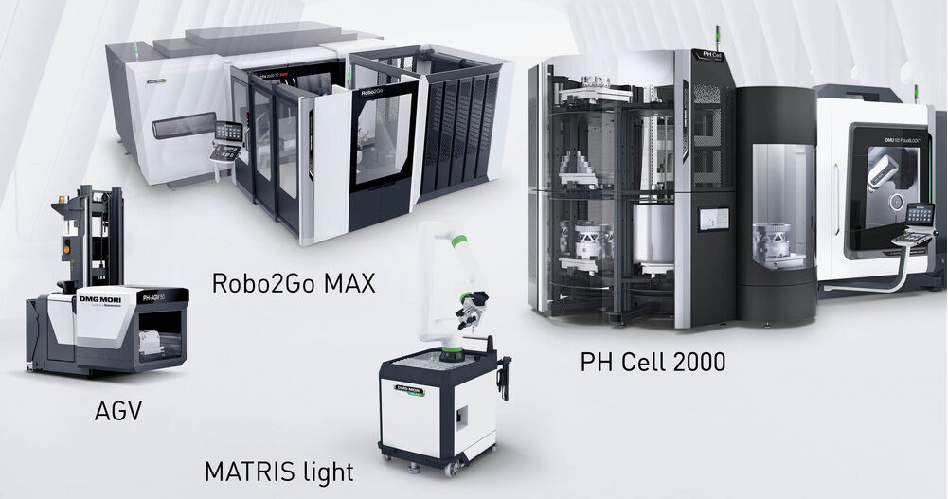
03
DMG MORI will be presenting 14 holistic automation solutions live at the in-house exhibition, including four innovations: Robo2Go MAX, MATRIS light,
PH Cell 2000, and PH 50.

Gear Cutting - gear machining on standard machines:
60 percent faster programming with DMG MORI gear cutting solutions
Gears are an essential component in drive technology. The requirements for the often safety-relevant and also very complex components are correspondingly high and diverse. In the past, special machines had to be used for this reason. With DMG MORI technology cycles, the expensive special path is now a thing of the past. The highlight: The complex NC programs can even be calculated on site directly at the control. Users are guided to the perfect machining parameters in dialog. Up to 60 percent time can be saved compared to traditional programming. Because it is a pure software solution, gear cutting can be integrated into both new and many existing machines. With gearSKIVING, gearMILL and gearBROACHING, DMG MORI offers innovative technology cycles that support efficient machining of high-precision gears with digital added value.

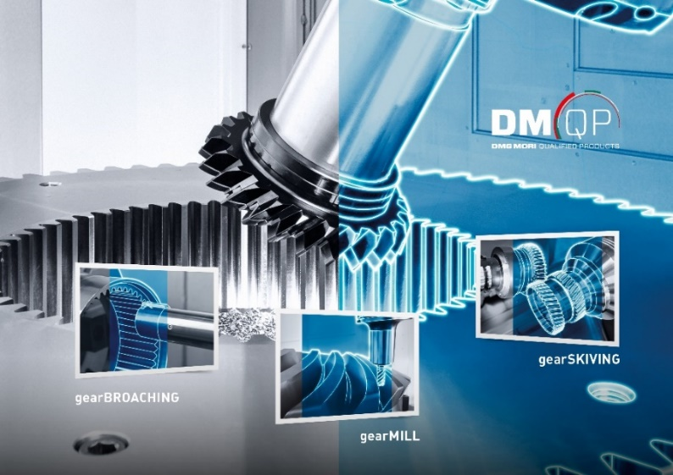
04
With gearSKIVING, gearMILL and gearBROACHING, DMG MORI offers innovative technology cycles that enable efficient machining of high-precision gears – without the need for special gear cutting machines.

Digitization: DMG MORI Cell Controller
Master computer for automated manufacturing systems
The new CELL CONTROLLER LPS 4 from DMG MORI is capable of integrating all individual machines, cells and manufacturing systems on the store floor into a flexible manufacturing network. In addition, the also controls the automatic supply of materials, tools and operating supplies via autonomous transport vehicles (AGVs). Finally, the new DMG MORI API seamlessly connects the store floor network with higher-level systems such as APS, MES and ERP.This opens a window for users into the digital future of the self-determined store floor. Because in addition to the traditional focus as a singular control center for manufacturing systems, the new DMG MORI master computer can be used to bidirectionally manage, plan, control and monitor the entire manufacturing process.
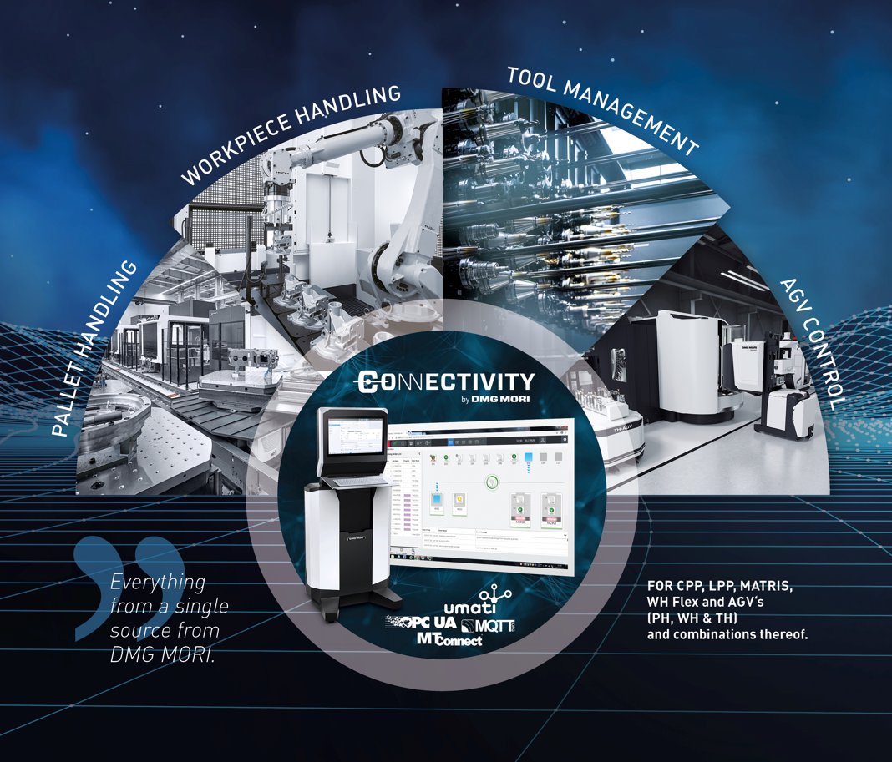
05
The DMG MORI Cell Controller LPS 4 is a master computer that offers "everything in one", from pallet and workpiece handling to the control of
driverless transport vehicles (AGV).

Digitization: DMG MORI Digital Twin
Faster production ramp-up and lower costs
Today, with every real machine tool from DMG MORI, its virtual image is created in parallel as a DMG MORI Digital Twin. In addition to far-reaching advantages in the run-up to installation, including in the engineering of manufacturing systems that can be flexibly automated, the added value of the digital twin now comes even closer to the customer's core processes. The DMG MORI Digital Twin as a dynamic image of all components, functionalities and axes as well as all control functionalities of NC and PLC – including the relevant cycles. The results are fascinating: The production ramp-up shines with a speed increase of 40 percent, costs are reduced by up to 30 percent and collisions are completely avoided.

Digitization: DMG MORI Tooling
With barcode to efficient tool management
Correct master data is fundamentally important for efficient tool management. For newcomers, the recording alone means a high initial effort, which often prevents the step into the modern age. This is now changing: With DMG MORI Tooling, the complete tool data set is just a scan away. This means that all geometry information in the incoming goods department can simply be uploaded to the company's own database via barcode. Scan-by-scan, DMG MORI Tooling thus creates maximum convenience on the way to professional tool management. The promise of convenience also extends to the procurement process.

World premiere: NTX 500
42.000 min⁻¹ compactMASTER turn & mill spindle for high-speed and micro- machining
The continuing trend towards increasingly complex workpieces requires extremely versatile manufacturing solutions. With the NTX series, DMG MORI has turn & mill complete machining centers in its product range that enable productive manufacturing of bone plates or implants in demanding industries and especially in medical technology. The NTX 500 is the new entry-level size here. The most compact model in the series offers a working area for workpieces up to ø 120 x 558 mm. As with its larger sister models, the heart of the NTX 500 is a high-speed Turn & Mill compactMASTER spindle with +/- 120° swivel range for absolute flexibility in 5-axis simultaneous machining. The Y-axis moves by 150 mm. In addition, the turn & mill center allows highly productive 6-sided complete machining of demanding workpieces.

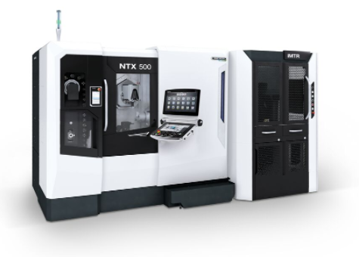
06
With a footprint of less than 7 m², the NTX 500 is ideal for high-speed and micro-machining of complex workpieces, for example for medical technology.

World premiere: DMU/C 85 H monoBLOCK
Process-reliable 5-axis universal machining up to 1,000 kg
With the DMU/DMC H monoBLOCK series, DMG MORI has successfully implemented its customers' requirements for flexibility, process reliability and automation capability. Now the machine tool manufacturer is presenting the new DMU 85 H monoBLOCK and DMC 85 H monoBLOCK in the variant with pallet changer as a consistent expansion of the series. The new size aims in particular at users from the mechanical engineering, die & mold, aerospace and semiconductor sectors. Thanks to the ideal chip fall, horizontal 5-axis simultaneous machining allows absolutely process-reliable production of complex workpieces. In the case of the DMU/DMC 85 H monoBLOCK, traverse paths of 850 x 1,150 x 900 mm serve a wide range of components. The solid basis for precise machining is ensured by the inherently rigid machine bed, the horizontal gantry concept, the thermosymmetrical design and the holistic cooling concept.

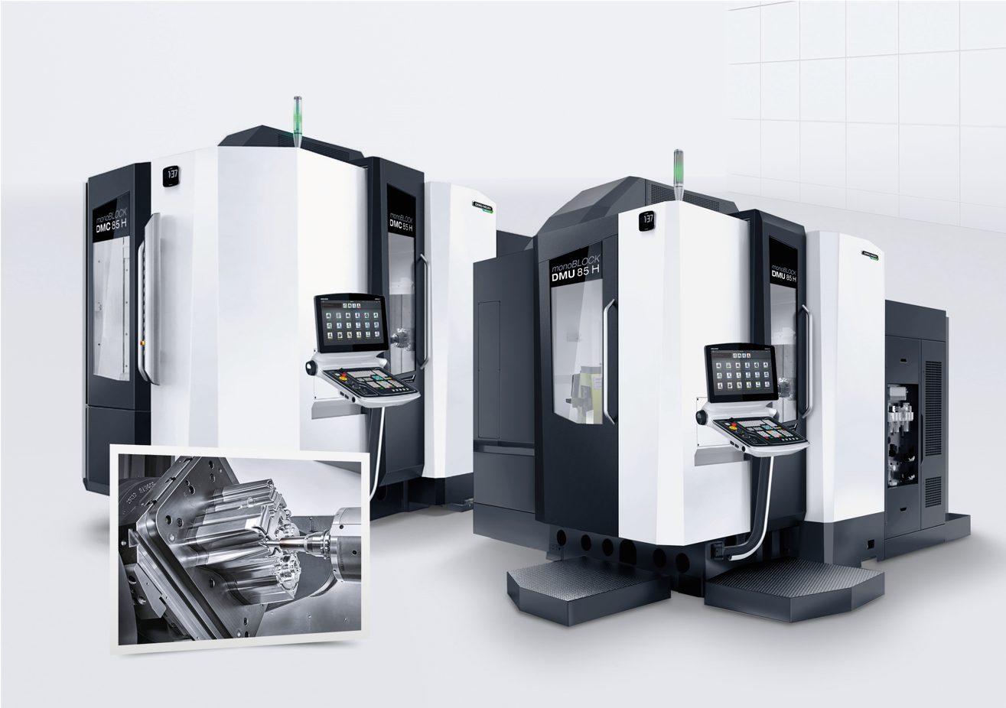
07
The new DMU/DMC 85 H monoBLOCK aims in particular at users from the mechanical engineering, die & mold, aerospace and semiconductor sectors.

